3M™ CLEAN-TRACE™ SURFACE PROTEIN PLUS
INSTRUCTIONS FOR USE

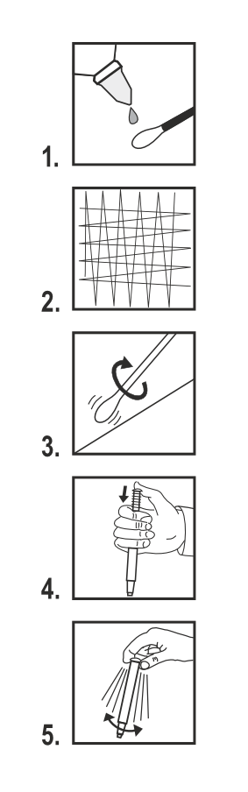 | 1. Place the clean-trace tests at room temperature for at least 10 minutes before use. Grip the sample stick handle and remove the swab from the device. If using upon a dry surface, moisten the swab by placing under a running tap of clean potable water [figure 1].  2. Swab the test area. Where practical, swab an area approximately 10 cm by 10 cm and swab the area in one direction and then swab the area in the opposite direction. [figure 2]. Apply pressure on the swab and rotate the swab as the sample is collected to ensure repeatable and effective sampling [figure 3].  3. Reinsert the sample stick into the device with the handle inserted to the original position of the unused device.  4. To process the sample, push down firmly on the top of the sample stick handle [figure 4]. The handle will slide into the device tube and the top of the handle should be level with the top of the device tube when fully depressed. Grip the top of the device and shake rapidly side-to-side for at least five seconds to mix the sample and reagent [figure 5]. The solution will turn mint green.  5. Set a timer for 10 minutes and incubate the swabs at room temperature and in a vertical position. After the ten minute time period, compare the color of the swab and the solution against the color chart on the Clean-Trace Surface Protein Plus label.

How to best utilize the Clean-Trace hygiene test:
DO | DON’T
hold the device in the VERTICAL position on activation and shake rapidly from SIDE TO SIDE for at least 5 seconds | activate while holding out of the vertical, do not shake up and down, do not shake like a thermometer.
incubate devices vertically | incubate devices horizontally
read at 10 minutes | record any color change after 10 minutes

Interpretation of Results
The color of the test reaction will indicate the level of protein residues on the surface. By comparing the color produced against the Clean-Trace Surface Protein Plus label an estimation of the surface cleanliness can be made.
• Green indicates a Pass result - Clean, No further action required
• Grey indicates a Caution result - Re-rinse
• Purple indicates a Fail result - Re-clean & Re-test

Shelf life and storage requirements
For maximum shelf life, store between 2° - 25°C (36° - 77°F).
3M™ CLEAN-TRACE™ SURFACE PROTEIN PLUS

Description:
The 3M™ Clean-Trace™ Surface Protein Plus test detects protein from food residues and other sources. The Surface Protein Plus test can also detect other reducing substances present in food residues.

The test is time- dependent, i.e. the color develops with time, therefore disregard any color change after the 10 minute period. With higher levels of contamination, color may develop more rapidly - there is no need to continue timing once the color changes to purple.

The test is temperature-dependent and therefore it is important to allow the devices to reach ambient temperature (15-25°C) before performing the test.

The Clean-Trace Surface Protein Plus test is not intended as a microbiological monitoring tool but may detect bacteria in excess of 10⁷ cfu/test. The color may form on the swab more than the solution with certain types of soil. Record the strongest color change on the swab or in the solution as the end result.

Applications:
To rapidly assess the standards of hygiene and sanitation procedures for surfaces and equipment.

Warnings:
Consult the Material Safety Data Sheet for additional information and local regulations for disposal.

Cautions:
Protein is a common substance. It is present on skin, hair and on many surfaces. Do not touch the swab or the surface to be tested.

Do not use devices past expiration date.

Do not store in direct sunlight.

Although the Clean-Trace Surface Protein Plus test is very sensitive, a surface cannot be considered sterile on the basis of a Clean-Trace Surface Protein Plus test result.

There is minimal interference with most common sanitizers at normal concentrations. However high concentrations of alkaline cleaners may cause false negative results in some instances. Peroxide based disinfectants can cause a false positive color change reaction with the Clean-Trace Surface Protein Plus test.

User Responsibility:
When selecting a test method, it is important to recognize that external factors such as sampling methods, testing protocols, sample preparation, handling, and laboratory technique may influence results.

It is the user‘s responsibility in selecting any test method to evaluate a sufficient number of samples with the appropriate matrices and challenges to satisfy the user that the chosen test method meets the user‘s criteria.

It is also the user‘s responsibility to determine that any test methods and results meet its customers and suppliers requirements. As with any test method, results obtained from use of this product do not constitute a guarantee of the quality of the matrices or processes tested.

